South West Water Bodmin Depot Map

Address:
Homefield Park
Bodmin
PL31 1DW

Samples should be left at the collection point by 14:00 at the latest Monday – Friday, excluding bank holidays.

When you enter the depot, keep going down and to the right. The bottle store is on the right-hand side. Key access is required to the bottle store, the access code is: 1067.

Important Health & Safety information

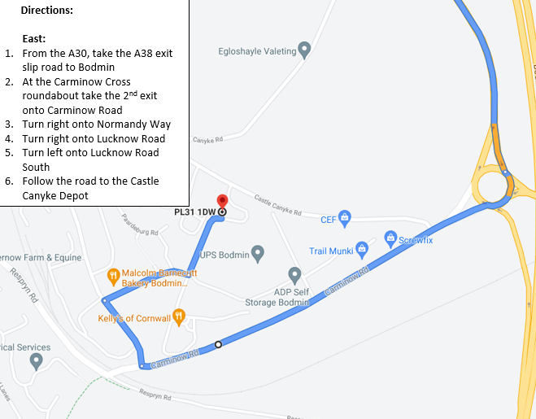
Please be aware that this is a working depot and, for health and safety reasons, please be aware of traffic on the site at all times. The site operates as a one-way system, the entrance into the site is via Lucknow Road South and, exits onto Castle Canyke Road.





