South West Water Exeter Laboratory Map

Address:
Scientific Services Laboratory
Bridge Road
Exeter
EX2 7RZ

Samples should be left at the drop off point between 8:30 and 16:30, Monday – Friday, excluding bank holidays.
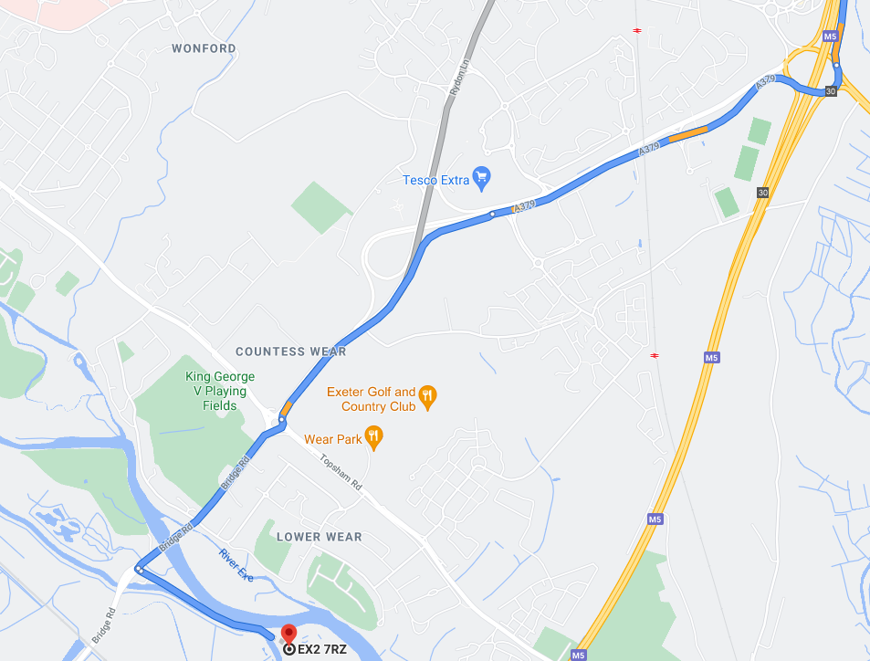
Directions:
East:
- From the M5, at junction 30 take the A379 exit to Exeter
- At the Sandygate Roundabout take the 3rd exit onto A379
- Keep left and merge onto Rydon Lane
- At the roundabout take the 2nd exit onto Bridge Road
- Turn left and keep left until you reach the Exeter Laboratories

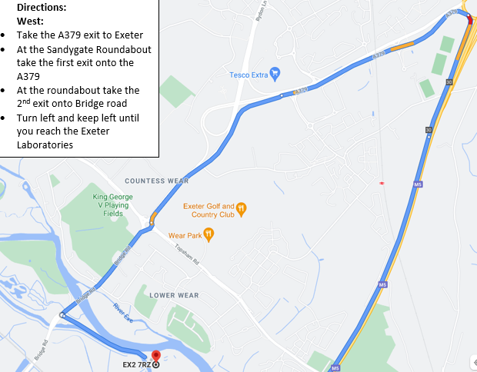
Directions:
West:
- Take the A379 exit to Exeter
- At the Sandygate Roundabout take the first exit onto the A379
- At the roundabout take the 2nd exit onto Bridge road
- Turn left and keep left until you reach the Exeter Laboratories

