South West Water Tolgus Depot Map

Tolgus Yard,
Tolgus Mount,
Redruth,
TR15 3TA

Samples should be left at the collection point by 13:00 at the latest, Monday – Friday, excluding bank holidays.

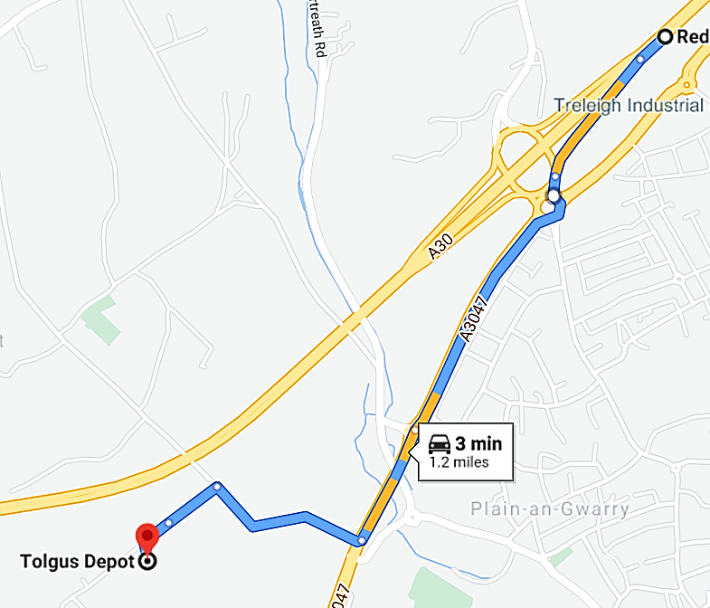
Directions from the East:
- From the A30, take slip road to Redruth/Porthtowan.
- At the 1st roundabout, take the 1st exit onto A3047.
- At the 2nd roundabout, take the 4th exit continuing onto the A3047.
- At the 3rd roundabout take the 1st exit, then take the 1st right.
- Take the 1st left then keep left and the Tolgus depot is on the left.

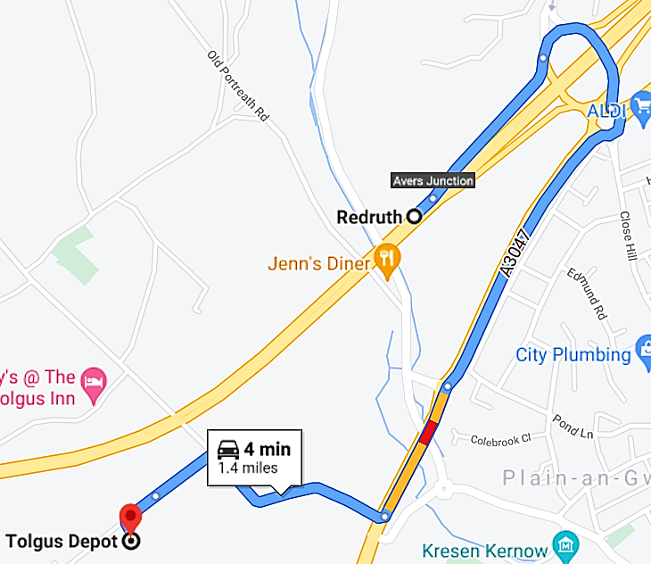
Directions from the West:
- From the A30, use Avers Junction to follow signs for A3047.
- At the 1st roundabout, take the 3rd exit.
- At the 2nd roundabout, take the 4th exit.
- At the 3rd roundabout, take the 1st exit and stay on the A3047.
- Then take the 1st right.
- Take the 1st left then keep left and the Tolgus depot is on the left.

